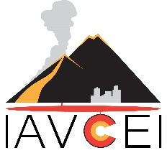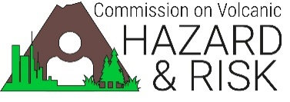

**Request to obtain copyright permission from [Insert Name or Institution]**

**Requestor**

International Association of Volcanology and Chemistry of the Earth’s Interior (IAVCEI) Volcanic Hazard Mapping Working Group.

**Requested material**

Volcanic hazard maps authored, produced and/or published by [Insert Name or Institution] .

**Purpose**

Publication of volcanic hazard maps as part of the following projects:

* + Publication of an open-access sourcebook on the development of volcanic hazard maps that will include guidelines and considerations. The Sourcebook will be published by Springer Nature Switzerland AG and distributed under the terms of the Creative Commons Attribution 4.0 International License (http://creativecommons.org/licenses/by/4.0/), which permits use, duplication, adaptation, distribution, and reproduction in any medium or format, as long as appropriate credit is given to the original author(s) and the source, a link is provided to the Creative Commons license, and any changes made are indicated. The electronic edition of the Work will be clearly labeled as “open access content” and contain an open access flag in the Publisher’s product database (currently SpringerLink). The publisher has the right to set the sale price for any printed version.
  + Development and online publication of an electronic database containing metadata from all available volcanic hazard maps, thumbnails of map images, and links to the official published versions of maps.
  + Open access publication of the results of a global survey on volcanic hazard maps carried out to analyse the ways hazard maps have been developed in the past.
  + Publication of other open access research articles directly related to the projects above.

All the above outputs of the IAVCEI Volcanic Hazards Mapping Working Group will be freely available on a new website dedicated to volcanic hazard maps: “Volcanic Hazard Maps”. The intended audience is anyone who has an interest in volcanic hazard maps, including volcanologists, emergency managers and the public.

**Permission**

[Insert Name or Institution] , as Copyright Owner of the material described, grant permission for the IAVCEI Hazard Mapping Working Group to copy the material as requested for the stated purposes, with no further action required.

Name and job title of person with authority to sign on behalf of the Copyright Owner

Signature:   Date:

**Attribution statement:**  
(please note any specific instructions you would like included in our acknowledgement of Copyright Ownership)

**Terms and conditions:**  
(please note any terms and conditions of the permission)

- Please fill in and sign this form and return to admin@volcanichazardmaps.org -